Step 1: Login to the Greenbush Marketplace
https://shop.equallevel.com/greenbush/login

Step 2: Search Swank in the search bar
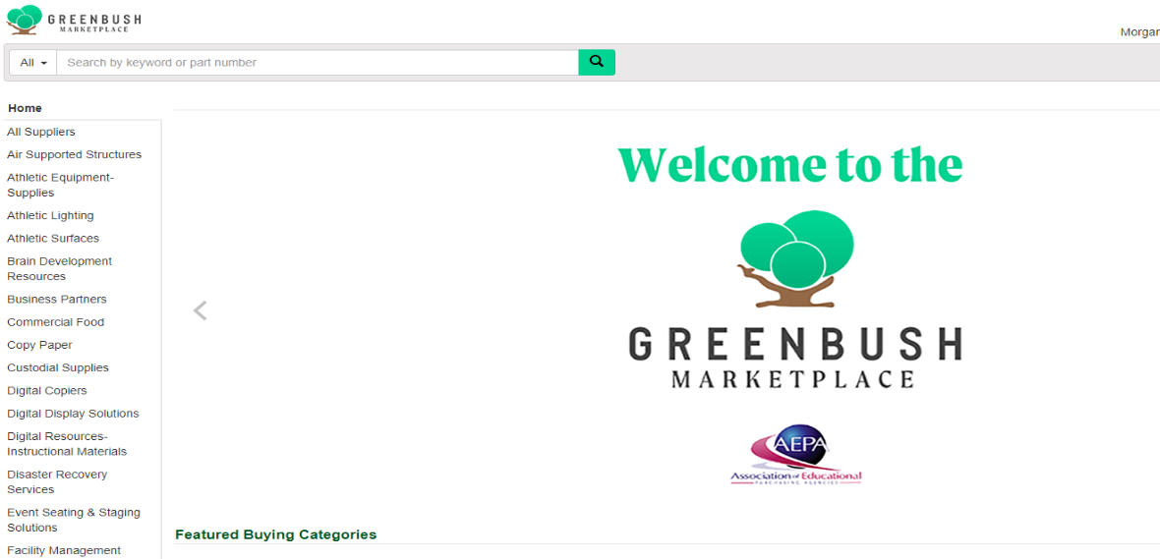

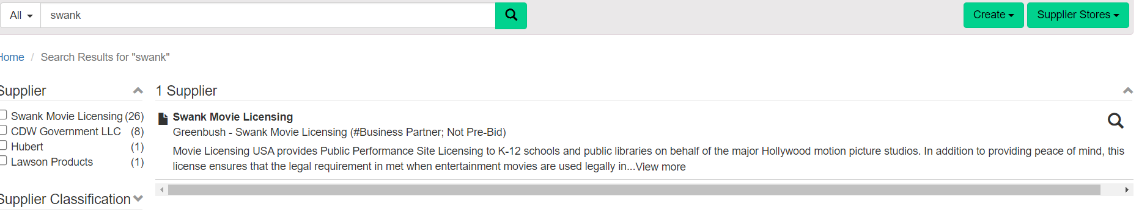
Step 3: Select Swank in the results.

Step 4: Search Catalog option on the right side of the pop-up box

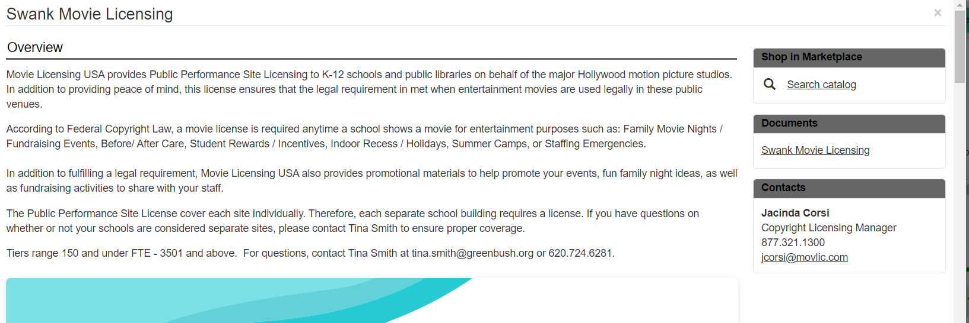

Step 5: Select the green “Search” button.
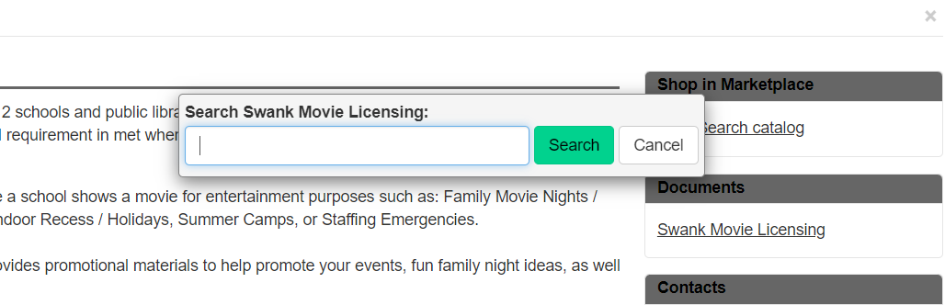

Step 6: Each license is for an individual school, not a district. Select the license based on the school enrollment and click “Add to Cart.”

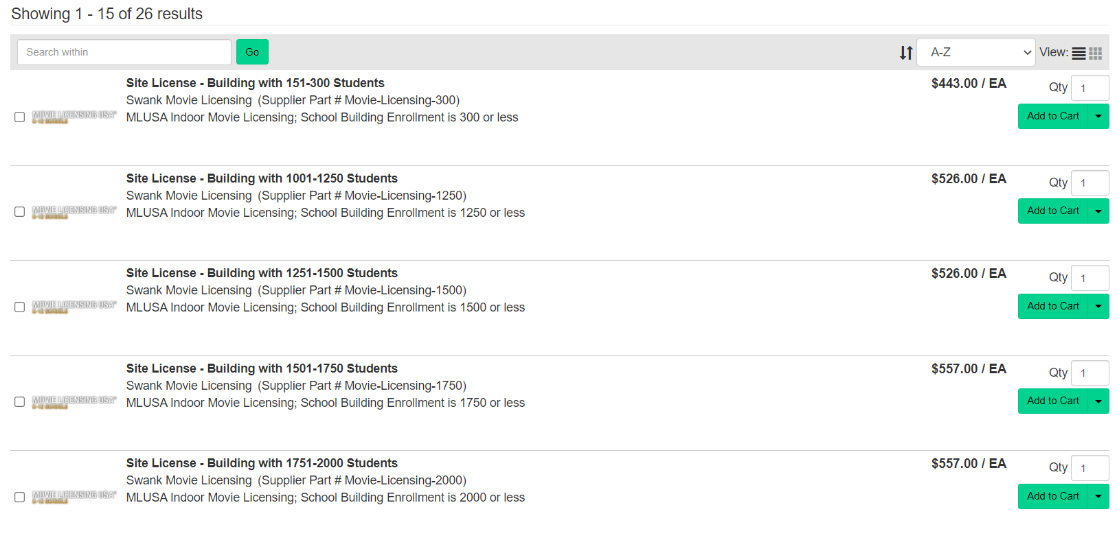

Step 7: Select “View Cart” or if you need to add more licenses, choose “Continue Shopping” from the pop-up window.

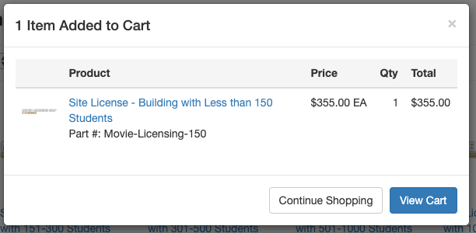

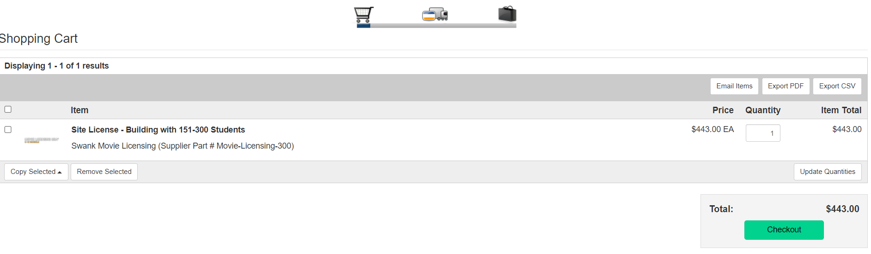
Step 8: In the cart, select the green “Checkout” button.

Step 9: Fill out your Shipping/Billing/PO information at the top of the screen. PO’s must be made out to Southeast Kansas Education Service Center (Greenbush) as you will be invoiced by Greenbush.
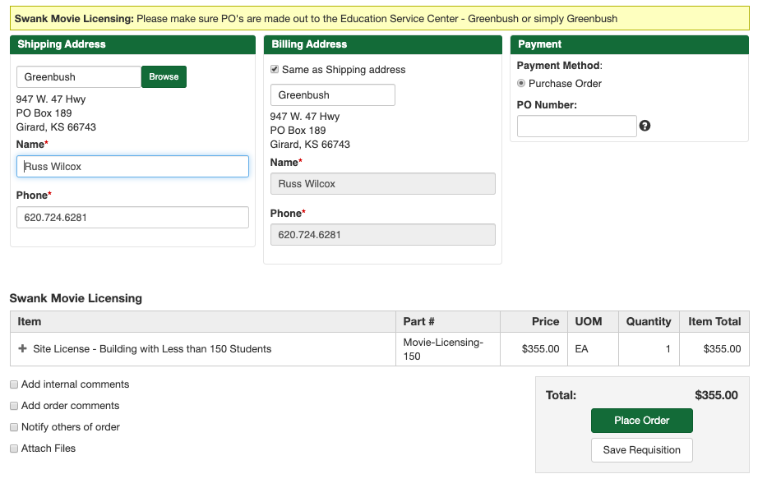

Step 10: Select the box that says, “Add Internal Comments.” In that box include the name of the school that the licensing is going to. If you are adding more than one school, separate each one by a comma.
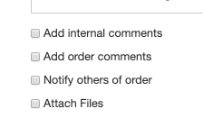
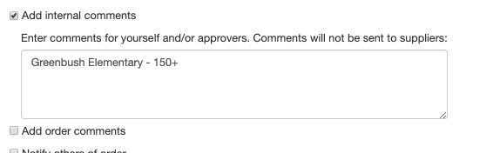

Step 11: Select the green “Place Order” button.
