Step 1: Login to the Greenbush Marketplace
https://shop.equallevel.com/greenbush/login

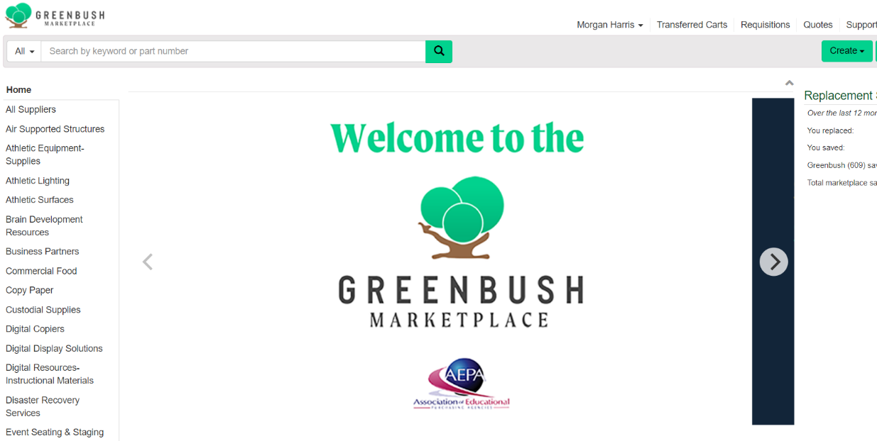
Step 2: Select “Copy Paper”

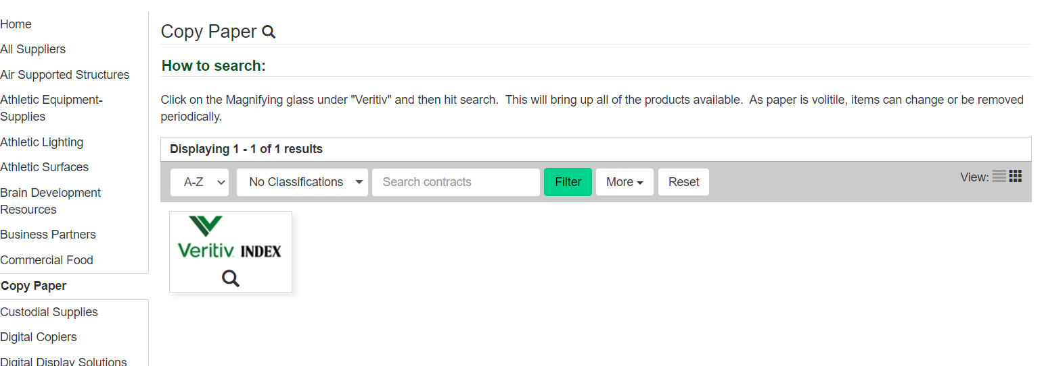
Step 3: Select the “Veritiv” icon

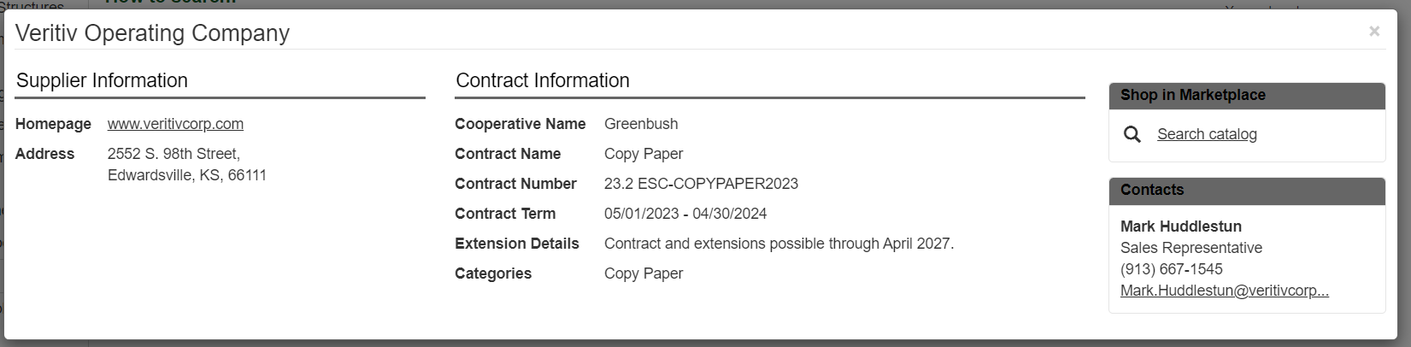
Step 4: In the pop-up box, select “Search Catalog.”

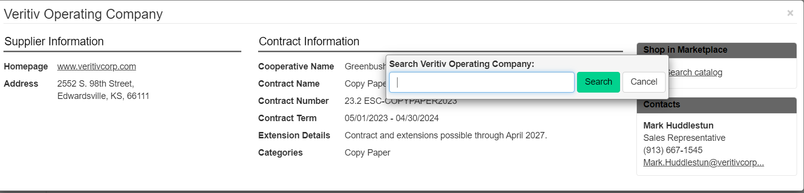
Step 5: Select “Search”

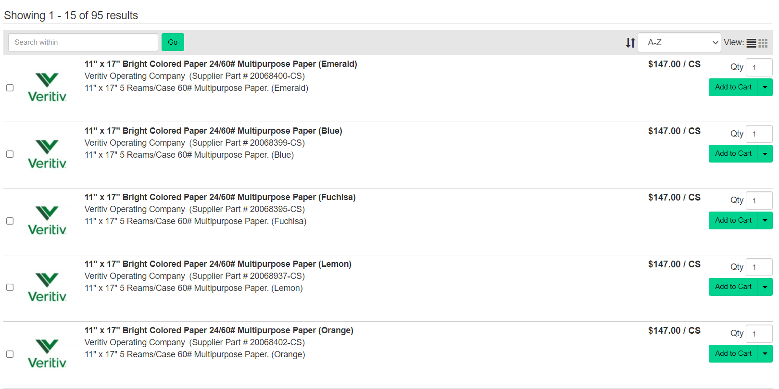
Step 6: A list of items will be displayed. Once you have found the item you’re looking for, select “Add to Cart.”

Step 7: Once you have added an item to your cart, a pop-up box will appear. Select either “Continue Shopping” to add more items to your cart or if you are finished shopping select “View Cart.”
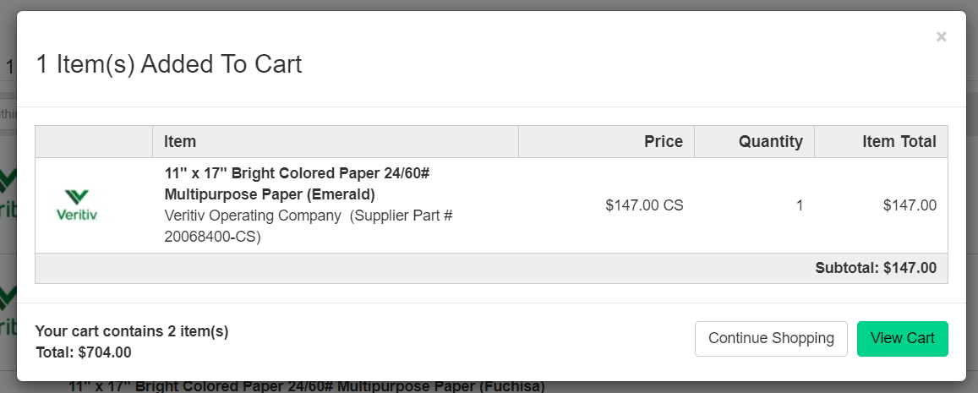

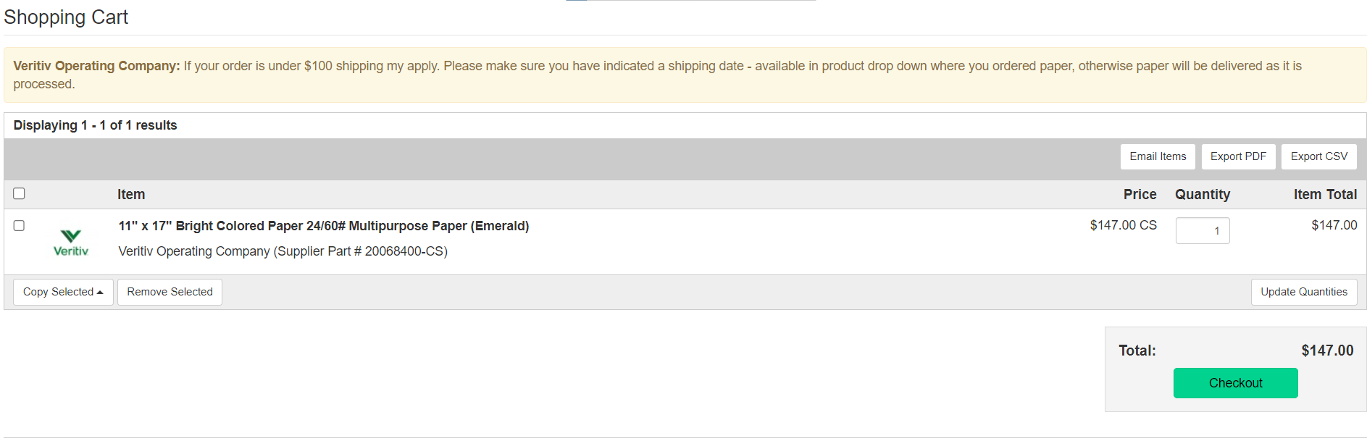
Step 8: In your cart, a yellow banner will be displayed with information regarding shipping fees.
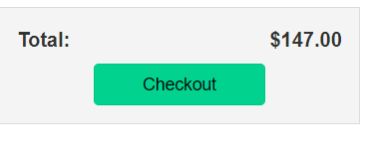
Step 9: Select the green “Checkout” button.

Step 10: On the checkout page you will include your shipping, billing & payment information.
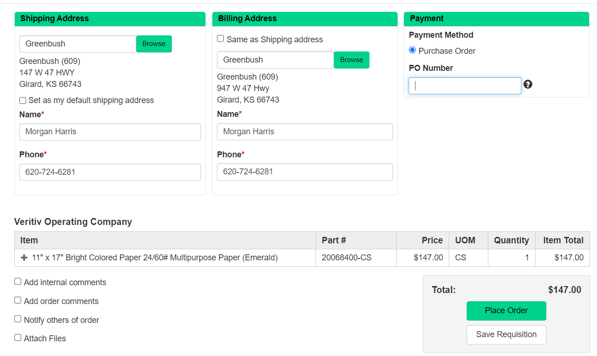

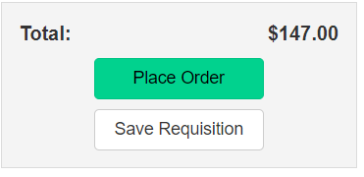
Step 11: Select the green “Place Order” button.

