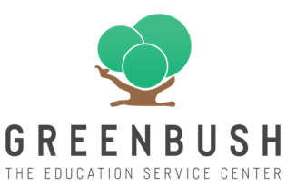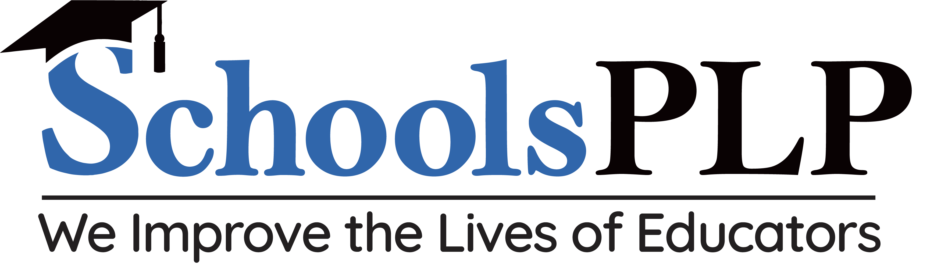
What is SchoolsPLP
&
How is it different than what I currently use?

- SchoolsPLP is used for Credit Recovery, Alt Ed, Electives, Certifications, and CTE

- SchoolsPLP competes with programs like Edgenuity, Odysseyware, APEX, and Acellus

- How is it different than what I use today? SchoolsPLP’s “Netflix Meets Education” learning approach keeps students better engaged in learning. Our modern courses use current fonts, bright colors, high quality graphics, and short, engaging videos with fast moving content. Videos range from :30 seconds to 4 minutes.

- Course Catalog: Our catalog has up to 1,400 courses. Including Electives, Certifications, and CTE. i.e. Coding, World Languages, Career Exploration, Photoshop, Drones, QuickBooks, OSHA 30 Hour, Cosmetology

- Virtual Instructional Services: SchoolsPLP can provide VI Services, including teacher of record for schools that need help finding staffing. Spanish, Chem, Bio, Physics, and many more.

- Pricing: Options start at $130 a year for an enrolled license or per $310 concurrent

To Learn More:
Register at www.edslearn.com
(These are weekly 30-minutes calls giving an overview of the SchoolsPLP student experience)
Or
Book a 1-1 Meeting
Aaron Eusterwiemann
913-424-2128
aarone@educationaldesignsolutions.com

