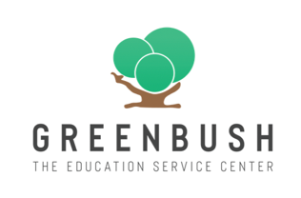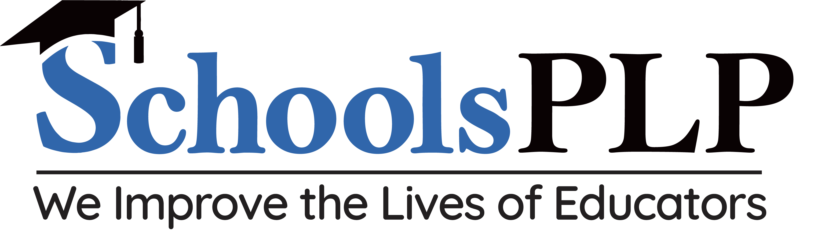
Reduce your Credit Recovery Spend

SchoolsPLP competes with programs like Imagine Learning, Edgenuity, Odysseyware, APEX, and Acellus. Many of these are nearing $1,000 per license.

SchoolsPLP starts at $310 a concurrent license or $130 enrolled. We have saved Districts $1,000’s vs. their current program, but MOST IMPORTANLY – WE HAVE A BETTER PROGRAM FOR YOUR STUDENTS!!!

- We can help “Small Schools do Big School Things” Beyond Credit Recovery, we offer 400+ Electives, Certification Prep, and CTE. Giving you access to courses like Health Sciences, Coding, World Languages, Career Exploration, Photoshop, Drones, QuickBooks, OSHA 30 Hour, Cosmetology.

- How is SchoolsPLP different than what I use today? Our “Netflix Meets Education” course design keeps students better engaged in learning.

- Beating the AI BOTS – while ensuring Student Integrity & Rigor – AI BOT Programs like EdgyPro & ExudusBOT will take the entire course for student, while mimicking student behavior. SchoolsPLP has several ways we detect & prevent AI BOTs & other cheating, while offering higher quality rigor in our courses.

- Virtual Instructional Services: SchoolsPLP can provide VI Services, including teacher of record for schools that need help finding staffing. Spanish, Chem, Bio, Physics, and many more.

- SchoolsPLP is used for Credit Recovery, SPED, Alt Ed, Electives, Certifications, and CTE

To Learn More:
Register at www.edslearn.com
(These are weekly 30-minutes calls giving an overview of the SchoolsPLP student experience)
Or
Book a 1-1 Meeting
Aaron Eusterwiemann
913-424-2128
aarone@educationaldesignsolutions.com

